**Trustee Recruitment Information 2023**

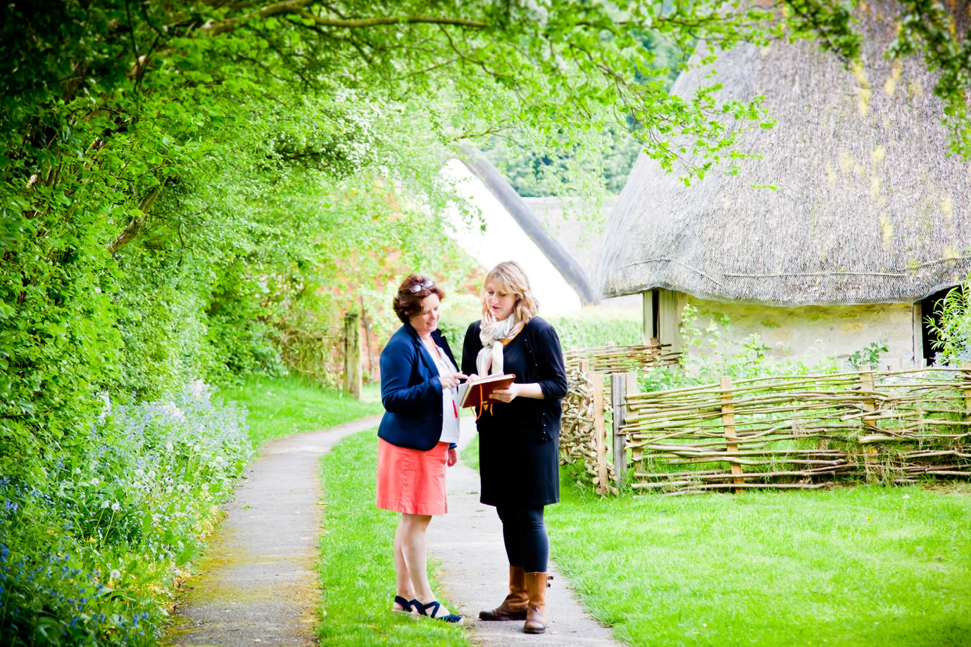

**About us**

Ryedale Folk Museum is an open-air museum with twenty historic buildings and a varied programme of events and exhibitions, through which our visitors can explore the history and daily lives of North Yorkshire people from the Iron Age to the 20th Century. Located in the picturesque village of Hutton le Hole in the North York Moors National Park, the museum was established in 1964, although its first origins began in the 1930s.

Now, our purpose is to make a positive difference to people’s lives in Ryedale and across the North York Moors, contributing to the sense of place and identity for the area, its communities and its visitors. We do this by:

* Putting people at the heart of what we do.
* Creatively using our collections and buildings to support the needs and wellbeing of the community.
* Working collaboratively with local people, so that their stories are gathered, represented and shared in a way that truly reflects them.
* Being a place where people arrive curious and leave inspired.

You can find copies of our annual report at <https://www.gov.uk/find-charity-information>. We are listed as Ryedale Folk Museum and our registered charity number is 1145218. We are also a company limited by guarantee (company number 07889200).

The day to day running of the museum is undertaken by a core team of seven staff (approximately five full time equivalents), supported by around sixty volunteers.

**Why join us?**

Having been established for over 50 years, we now want to look to the future for Ryedale Folk Museum, to ensure that we can continue to be a thriving venue for our visitors and community for the next 50 years and beyond. We have recently completed a new ten-year strategic plan for the museum. As a trustee, you will have the opportunity to help us deliver our strategic aims, contributing to a thriving and sustainable future for the museum. We are a friendly board, open to new thinking, and are keen for people with a wide range of skills and experience to be involved in our work. We aim to make your experience as a trustee both rewarding and enjoyable; and we offer support and development opportunities to help you grow your skills as a trustee, as well as a formal induction process. By joining us, we hope that you will have the chance to use your expertise to make a real difference to the museum and local area.

*“Being part of the Board, supporting our fantastic museum team and playing an active role in the museum’s development is hugely satisfying and enjoyable. I’ve gained an insight into operations, collections management, project ideas and funding, strategic and business planning, as well as collective decision making. Every meeting involves good discussion!”*

*Carolyn Lloyd Brown, Trustee since 2021*

**Who are we looking for?**

We are recruiting a Chair and two additional trustees who are forward thinking, open-minded, willing to contribute their time and effort, and who have a passion for the museum.

We are keen to welcome a diverse range of experiences and perspectives, including people who are new to the role of a trustee or who may be at the start of their career. We particularly welcome applications from people with disabilities, Black, Asian and Minority Ethnic candidates, as well as applications from LGB, Trans and non-binary candidates as under-represented people within the museum.

At present we are particularly seeking trustees with the following expertise and experience:

* fundraising strategy
* environmental issues and climate change
* farming or rural life
* marketing strategy

However, if you are interested in this role and feel that you have different skills to contribute, please apply, as all applications will be considered.

**Trustee role description**

|  |  |
| --- | --- |
| **Remuneration:** | This position is not remunerated but trustees can claim reasonable out of pocket expenses incurred fulfilling the duties of the role. |
| **Location:** | The museum is in Hutton-le-Hole, North Yorkshire, YO62 6UA. Meetings usually take place at the museum or nearby. We can also facilitate attendance at meetings via Zoom. |
| **Time commitment:** | Trustees are expected to attend meetings every three months (usually 5.30 - 7.30pm), an annual away day, and around four museum events a year. They are also expected to undertake some work in between meetings to fulfil their responsibilities. This includes preparation for Board meetings, delivering actions assigned at meetings, providing active support to the executive team where their expertise can add specific value, and taking part in training and development.  Some Trustees also sit on sub-committees, working groups or panels (e.g. Finance or Fundraising group).  Trustees are usually appointed for a term of three years with the option of reappointment for a further term. |

**Role summary**

Trustees have the ultimate responsibility for directing the affairs of Ryedale Folk Museum, and ensuring that it is solvent, well-run and delivers the charitable outcomes for which it has been set up.

Ryedale Folk Museum is registered as a charity and a limited company. Every trustee is also a director of the company and has legal responsibilities and potential liabilities in each capacity. For more details about the legal obligations of trustees, please visit [www.charity-commission.gov.uk](http://www.charity-commission.gov.uk) and follow links to the publication CC3 The Essential Trustee: What you need to know.

**Main responsibilities of the role**

The main responsibilities of trustees are as follows:

* + Contribute to the museum’s business plan, by setting objectives and evaluating performance against targets.
  + Ensure the financial stability and sustainability of the museum.
  + Ensure the museum is managed effectively and efficiently, including oversight of:
    - Care for the museum’s collection;
    - Site, property and buildings management;
    - Financial management, investment of funds and budgets;
    - Museum policies and compliance (e.g. Health and Safety, Safeguarding, HR).
  + Ensure that the museum complies with relevant legislation and regulations, in particular ensuring that the museum prepares and submits its reports, annual returns and accounts as required by law.
  + Ensure that the museum complies with the requirements and rules set out in its Memorandum and Articles of Association and ensure that the museum applies its resources exclusively to pursuing its objectives.
  + Keep informed about the activities of the museum and wider issues which affect its work.
  + Act with integrity, to avoid conflicts of interest or misuse of the museum’s funds or assets.
  + Use specific skills, knowledge and experience to help the board of trustees reach sound decisions, including taking the lead in any trustee activities where the trustee has particular expertise.
  + Attend and take an active part in trustee meetings and decision making.
  + Sit on any committees or panels as required (e.g. Finance committee; Fundraising committee; recruitment, grievance or disciplinary panels).
  + Be visible and regularly come to the museum, both attending events (e.g. art gallery openings, fundraisers) to engage with our visitors and getting to know our staff and volunteers to promote good working relationships.

**Trustee Person Specification**

Each trustee must have:

* Commitment to the purpose, vision and strategic objectives of Ryedale Folk Museum
* Willingness and ability to meet the time requirement for being an active trustee
* Readiness and ability to take on and deliver agreed tasks and projects
* Ability to make a positive and effective contribution to Board discussions and decision-making
* Ability to think strategically, focussing on major issues and decisions
* Ability to understand and fulfil the role and responsibilities of a charity trustee

**Conduct and eligibility**

Trustees are expected to act in accordance with the museum’s Code of Conduct at all times. There are certain restrictions on eligibility to become a charity trustee ie you cannot be under the age of 18, have previously been removed from trusteeship by a court or the Charity Commission, disqualified as a company director, or convicted of an offence involving deception or dishonesty (unless spent).

**Chair role description**

**Role summary**

The Chair will play a key role in leading the Board and ensuring that it acts in accordance with its duties, in ensuring that the museum is well governed, and in shaping its future direction and development in line with its current ten-year strategy.

The role is voluntary but reasonable expenses may be claimed. Over and above the time commitment expected of trustees, it is likely that the role will entail approximately 16-20 hours a month on average.

**Main responsibilities of the Chair**

The Chair’s responsibilities are to:

* Lead the Board in directing and monitoring delivery of the museum’s current ten-year strategy, of its policy framework, and in setting and evaluating clear, relevant and ambitious objectives.
* Ensure that the museum is well governed and that it operates in line with its Articles of Association, company and charity law, and with any other relevant legislation and best practice.
* Chair and facilitate Board meetings effectively and efficiently, ensuring their effective planning and conduct and that all decisions are taken in the best interest of the museum.
* Lead the Board in evaluating and improving its effectiveness and operation.
* Ensure that all trustees are fully engaged, contribute to meetings and to the trustee work programme, and fulfil agreed tasks and projects.
* Support the recruitment, selection and appointment of trustees to the Board and ensure that the development and training of trustees is appropriate and effective.
* Create opportunities for trustees to develop in their roles, delegate to them appropriately, provide and arrange support where necessary, and enable them to review their performance and contribution to the Board and the museum.
* Develop a positive and productive working relationship with the Director, provide support and guidance as appropriate, and conduct annual performance reviews.
* Lead the Board in exercising effective support and challenge to the Director and staff team, ensuring that it is properly advised and informed in its decision-making.
* Ensure that strategy and operations protect the museum’s financial sustainability and assets, and, liaising with the Treasurer and Director, maintain careful oversight of its financial performance and viability.
* Act as a visible ambassador for the museum, leading advocacy work with stakeholders, acting as spokesperson where appropriate, representing the museum at events, and supporting the Director and staff to raise the museum’s profile.

**Chair: person specification**

We are seeking applications from suitably qualified and experienced people who can demonstrate:

* An enthusiasm for the museum and strong commitment to its purpose
* Ability to think strategically, focussing on key issues, whilst also understanding and supporting the practicalities of operating an independent charitable museum
* In-depth understanding, and, ideally, first-hand experience, of what constitutes best practice in charity governance
* Ability to inspire and lead a high performing Board and to build a close and productive relationship between Board members and the Director and staff team
* Ability to harness the diverse views and contributions of every Board member in an inclusive and supportive manner
* Financial acumen, both in terms of understanding financial performance and trends and of strengthening and diversifying income streams
* Ability to build on existing networks and to act as an impactful and authoritative ambassador for the museum
* An understanding of the wider policy context in which the museum operates, including the heritage sector
* An understanding of the challenges facing small rural businesses and charities
* Knowledge of the North York Moors and its communities would be advantageous but is not essential

**Applications**

To apply for either role, please send a CV and covering letter detailing your relevant experience, why you are interested in the role, and how you meet the role description and person specification, to trustee@ryedalefolkmuseum.co.uk .

Please make it clear for which role you are applying (i.e. Chair or trustee) and provide the names and contact details of two independent referees who are able to comment on your suitability for the role.

For further information or to discuss the role, please message the above address with your telephone number and we will be in touch.

The deadline for applications is midnight on Friday 30 June 2023. We will invite successful applicants for a tour of the museum and an interview.

Following interview, the panel will recommend successful candidates to the Board for appointment. Feedback will be available to all candidates.

Please note that the process and timetable for both roles are the same.