Group Visitor Information
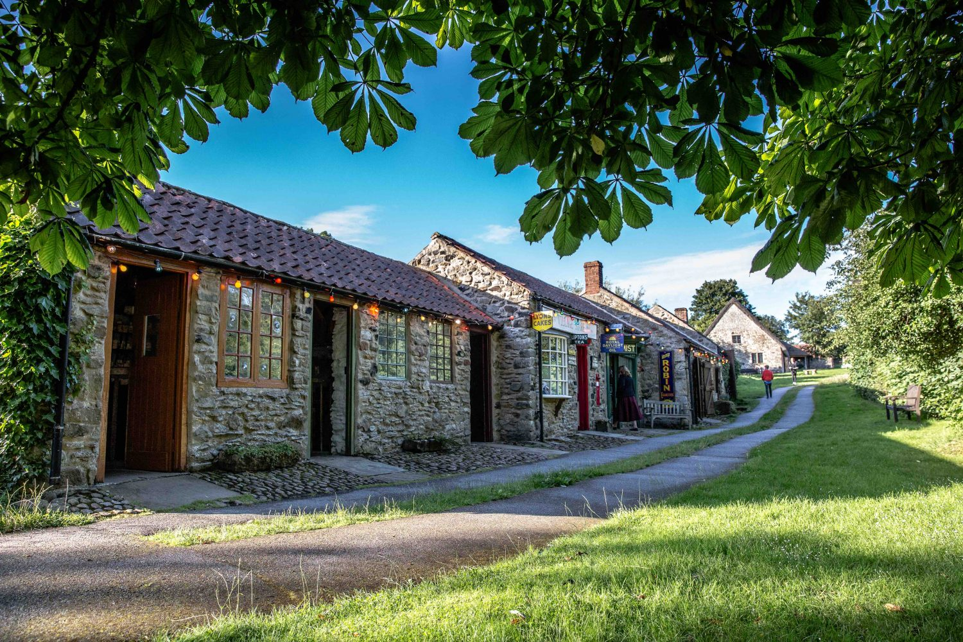
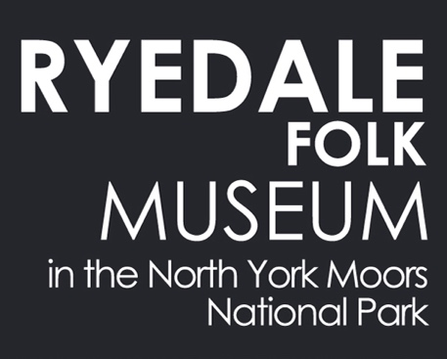

Hutton-le-Hole, YO62 6UA www.ryedalefolkmuseum.co.uk 01751 417367

www.ryedalefolkmuseum.co.uk

A unique visitor attraction located in the picturesque village of Hutton-le-Hole, where history is brought to life through its buildings and collections.
In a truly beautiful setting within the North York Moors National Park, Ryedale Folk Museum makes a wonderful choice for your group’s excursion. Your party can explore the site at their own pace, with twenty buildings and six acres to enjoy.

Step back in time and explore:

- A typical Iron Age roundhouse
- A Medieval crofter’s cottage
- A thatched Elizabethan Manor House
- An 18th Century thatched cottage complete with rare wooden witch post
- A Victorian thatched cottage, washhouse and dairy
- An array of horse-drawn vehicles – a hearse, fire engine, carriages and ploughs
- Traditional workshops of the blacksmith, cobbler, wheelwright, tinsmith, cooper, saddler and carpenter
- An Edwardian daylight photographic studio – the oldest in the country
- Vintage farming equipment – tractors, ploughs, carts and threshing machine
- A nostalgic 1950s village shop and chemist
- The Rosedale glass furnace: an insight into illegal 15th Century glass making

2023 Visit Times and Prices
Please note that the Museum is closed on Fridays.
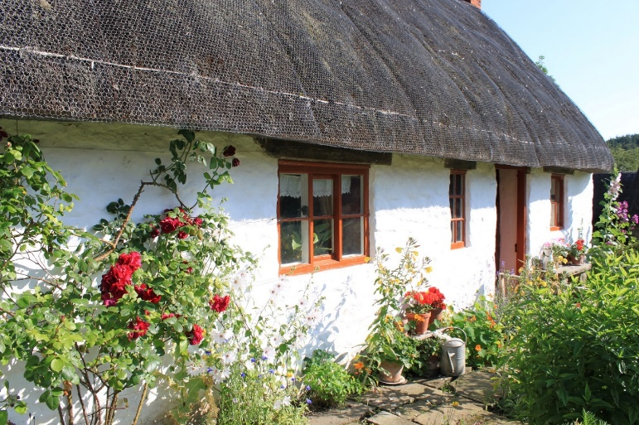
11 March – 31 March, 10am – 4pm
1 April – 31 October 10am – 5pm
1 November – 17 November, 10am – 4pm

Group Day Pass:
£7 per person (inc VAT)
For advance bookings of 10 or more.

Please note that all members of a group must arrive together and payment must be made by one individual or organisation.
Exclusive evening visits may be possible at an additional charge – subject to staff availability and daylight hours – please contact us if this is of interest.

Getting Here and Parking
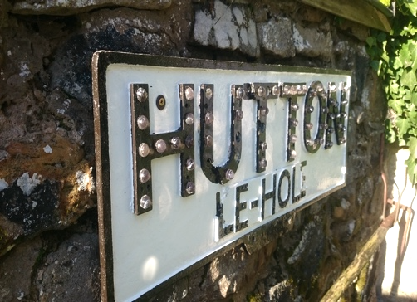
We are located in the village of Hutton-le-Hole, on the road from Kirkbymoorside that runs over ‘Blakey Ridge’ to Castleton. We are two miles north of the main A170 road between Helmsley and Pickering. The Museum is less than an hour’s drive from Whitby, York, Scarborough and Middlesbrough and around a one and half hour drive from Leeds and Hull.

Coach parking is available at the National Park Authority’s car park in Hutton-le-Hole, which is a 300m walk from the Museum entrance. Please confirm the current coach price with the North York Moors National Park Authority. Coaches can drop off/pick up passengers outside the Museum if required – whenever possible, a member of the Museum team will provide a short welcome and distribute tickets on your coach upon arrival – just send someone in to tell us you’ve arrived.

Car parking is available at the National Park Authority’s car park, which is a 300m walk from the Museum and at The Crown Inn car park, which is adjacent to the Museum. Charges apply at both car parks, please see our website for current rates (coins required).

We recommend that you allow at least two hours for your visit to make the most of the Museum and village.

Access and Facilities
Ryedale Folk Museum is an open-air Museum with historic buildings. There are a variety of floor and ground surfaces, some of which are uneven by nature. All buildings have ground floor access but unfortunately some buildings have one or two (mostly small) steps to enter them.
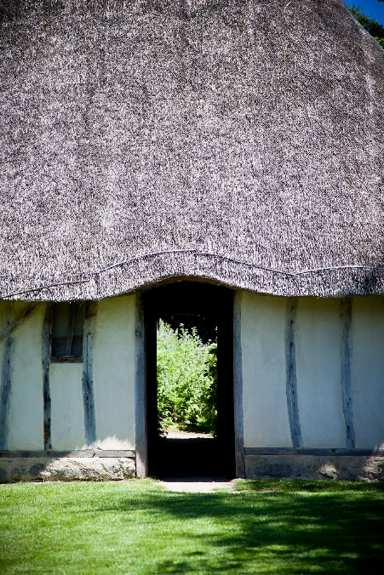
There is a gentle slope through the middle part of the site (around the main green area) and some manual wheelchair users may require assistance from a companion at that point. The Museum has two mobility scooters and two manual wheelchairs which are available to borrow free of charge. Booking before arrival is essential to guarantee availability. Our scooters are large and sturdy, helping people move around the site, but they cannot be taken into the buildings.

Toilets are available at two locations on site including disabled toilet facilities in both places. A baby changing facility is also available.

Shopping and Exploring
Gift Shop
Our gift shop offers a range of items for visitors to take home to commemorate their visit or as a gift for friends or family. We stock a range of books, toys, greetings cards, locally produced food and drink, as well as quality local hand-crafted items. All profits from the shop are used to support the Museum’s charitable activities.

The Village and the North York Moors National Park
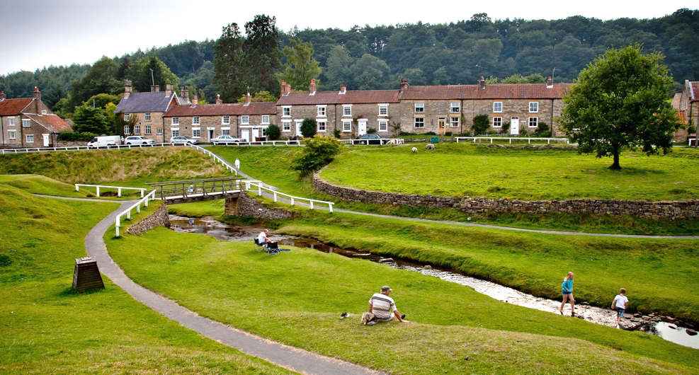
Hutton-le-Hole village, where the Museum is situated, is one of the most scenic villages in the area – with a babbling beck and grazing sheep. We would advise that your group allows time to appreciate its peaceful atmosphere and to visit the village’s craft workshops.

The wider area of the North York Moors National Park also offers your group the chance to explore one of Britain’s most beautiful areas of countryside.

Find out more by visiting the National Park’s website: www.northyorkmoors.org.uk

Food and Drink
There is a choice of establishments in the village, supplying everything from a quick cuppa to a tasty two-course meal. Each member of your group will receive a pass on arrival, allowing individuals the freedom to come in and out of the Museum, enjoying refreshments at their leisure.

Bookings can be made for refreshments for your entire group at a set time if preferred, please liaise directly with the establishment of your choice:

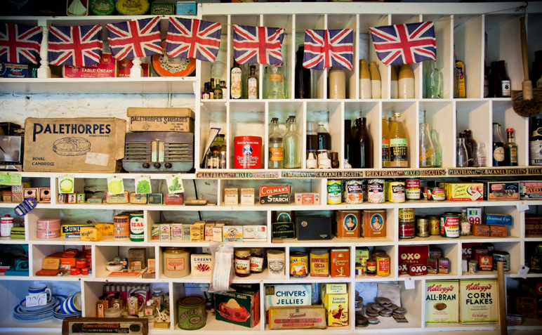
The Barn Tea Rooms - 01751 417311
www.thebarnguesthouse.com
info@thebarntearooms.plus.com

The Forge Tea Room - 01751 417444
www.theforgetearoom.com
enquires@theforgetearoom.com

The Crown Inn - 01751 417343
www.crownhuttonlehole.com
office@crownhuttonlehole.com
How to Book
Group bookings can be made by:
- Telephoning the Museum during opening hours
- Coming to the Museum in person during opening hours (familiarisation visits can be arranged – please email or call us to discuss your requirements)
- Returning the Group Booking Form via post/email

Your booking will be provisional until we confirm the details with you.
A Group Booking Form (if not included with this information) can be downloaded from our website: www.ryedalefolkmuseum.co.uk/visit
01751 417367
info@ryedalefolkmuseum.co.uk

Ryedale Folk Museum
Hutton-le-Hole,
North Yorkshire
YO62 6UA

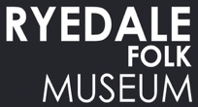
Group Booking Form

Group name

Contact name

Contact address
(with postcode)

Contact email

Contact telephone

When does your group want to visit?

Day and date |  | Approximate time of arrival

How many people are in your group? @ £7 per person

If you are unsure of exact numbers, please indicate ‘up to’ & the maximum number above.

Do any of your group require the use of a Museum wheelchair or mobility scooter?

No. of wheelchairs | 1 2 | No. of mobility scooters | 1 2 3

How will you pay for your visit? | Tick one
By cash, card or cheque on the day.
This payment option accounts for any last-minute changes to numbers.
By BACS in advance.
Ryedale Folk Museum, Sort code: 40-26-15 Account number: 31426443
Please state your group’s name as a payment reference and email notice of payment to: info@ryedalefolkmuseum.co.uk. Please note: refunds can not be given in the case of subsequent changes in numbers/no-shows.
Payment on invoice
This option is only available to companies with prior agreement/contract.

Additional notes / requirements:

Hutton-le-Hole, YO62 6UA info@ryedalefolkmuseum.co.uk 01751 417367

